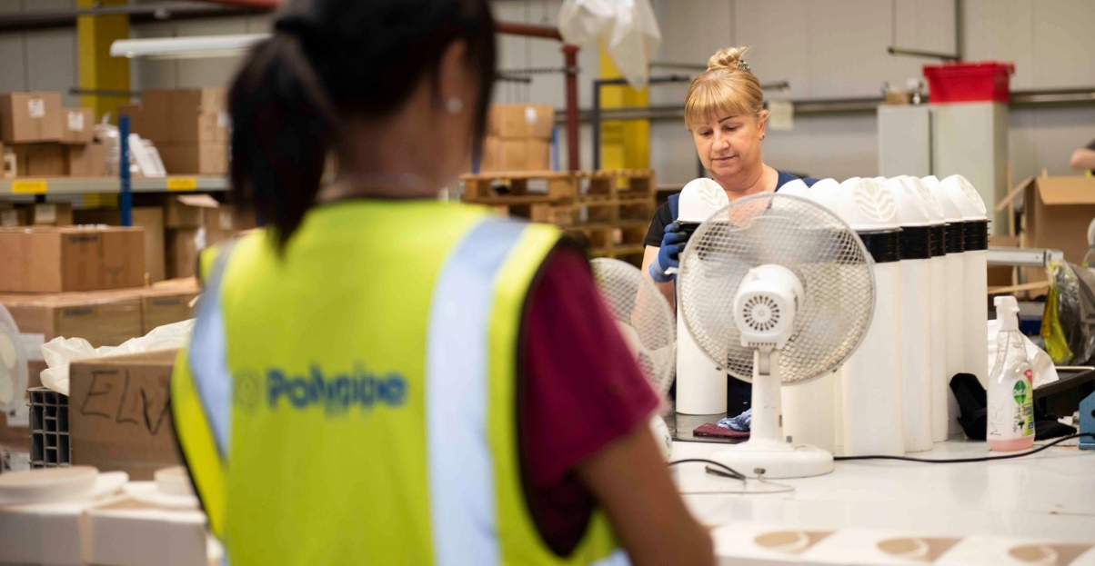
WE ARE

HIRING

POLYPIPE BUILDING SERVICES, NEW HYTHE BUSINESS PARK AYLESFORD, ME20 7PJ

EXTRUSION VACANCY

To be successful you will have:
- A willingness to undertake all production operating duties
- Ability to work under own initiative and have an aptitude for problem solving
- A demonstrable pro-active and positive approach to learning and development, showing willingness and flexibility
- Be self-motivated, committed and reliable with an excellent timekeeping/attendance record
- Experience of working as an Extrusion Technician including experience of tool changing and machine condition setting is desirable – a Trainee position would be considered for an exceptional candidate without extrusion experience.

We currently have a vacancy for a Production Technician to join our Extrusion Department at our Aylesford site.

Hours of work:
The position is 3 rotating shifts (6 am – 2 pm, 10 pm – 6 am and 2 pm – 10pm)
40 hrs per week - Monday - Friday

Key Accountabilities:

The Production Technician – Extrusion will be responsible for the manufacture of extruded products, completing product/tooling changeovers, undertaking process start-ups and shut downs, and problem solving/process optimisation. The role will also regularly support the team by undertaking duties such as packing, quality inspection, testing and processing support.

APPLY NOW!
If you think you are the perfect fit for the role, please send your application by email, with a current CV to:
Carl Pollard
Production Manager
Carl.Pollard@polypipe.com

Building Services
Polypipe Building Services operate an Equal Opportunities Policy

